**2.0 SYSTEM ANALYSIS**

System analysis is the way of studying a system with an eye on solving its problem using computer. It is the most essential part of the development of a project of a system analysis. System analysis consist of system element, process and technology. To a analyse a system, has to study the systems in details.

The analyst has to understand the functioning and concept of the system in details, before design the appropriate computer based system that will meet all the requirements of the existing system. The system analyst has to carry out a customary approach to use the computer for problem solving.

The above steps constitute the logical framework for the system analysis.

After the preliminary investigation and feasibility study, the scope of the define and comparable items are set forth and hence detailed investigation is execute. This allows the system analyst to comprehend the full scope of the project. Soon after the implementation of the newly developed system, followed by the training of the users, the system analysis is include.

**2.1 EXISTING SYSTEM:**

Currently there is no such system available. The users earlier need to login into official website. Therefore the need for a chat system facility was necessary. There is LAN network spread across various offices, so we can develop software which can work on LAN.

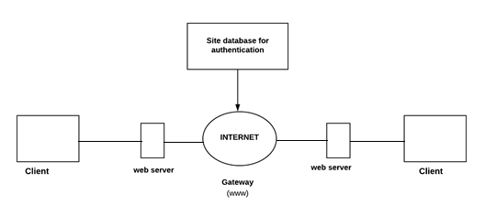

**2.1.1 No need of Internet connection:**

**Existing system requires Internet connection; whereas in the proposed system only Internet connection i.e. only a LAN connection is required. This system is useful for those who can not afford to have an Internet connection. For example: schools, college, small companies and etc.**

**2.1.2 Conference possible on LAN:**

**Usually on LANs connection conferencing is not possible. The proposed system allows the LAN users to create and participate in conference. This makes communications possible among number of LAN users simultaneously.**

**2.2 PROPOSED SYSTEM:**

* **The system to be developed here is a Chat facility.**
* **It is a centralized system.**
* **It is Client-Server system with centralized database server.**
* **All local clients are connected to the centralized server via LAN.**
* **There is a two way communication between different clients and server.**
* **This chat application can be used for group discussion.**
* **It allows users to find other logged in users.**

**2.3 REQUIREMENT ANALYSIS:**

**The primary goal of the system analyst is to improve the efficiency of the existing system. For that the study of specification of the requirement is very essential. For the development of the new system, a preliminary survey of the existing system will be conducted. Investigation done whether the up gradation of the system into an application program could solve the problems and eradicate the inefficiency of the Existing system.**

* **User must be able register with username, password, server name and port number.**
* **Adding/invite the friend**
* **User should be able to send instant message to any contact on his/her list.**
* **User should be able to create groups of contacts.**

**2.4 HARDWARE REQUIREMENT:**

**Server:**

* **Processor :- Dual Core**
* **Memory :- 1 GB**
* **Free Space:- 2 GB or above**

**2.5 SOFTWARE REQUIREMENT:**

* **Operating System:- Windows**
* **JDK 1.6**
* **NetBeans**
* **Java Environment**

**Network Requirement:**

* **LAN connection**

**2.6 JUSTIFICATION OF THE PLATFORM:**

**JAVA:**

* **Write once, run anywhere(WORA):**

**JAVA technology promises you that you only have to write your application once for the java platform and then you will able to run it anywhere.**

* **Security:**

**The capacity of java platform allows users to download entrusted code over a network and run it in secure environment in which can not do any harm. Because the security guarantee, nearly as strong as java makes.**

* **Performance:**

**Java is portable interpreted language java programs runs almost as fast as native non-portable C and C++.**

* **Program efficiency & Time-to-market:**

**Java is an elegant language combined with a powerful and well designed set of API. Java increases programmer efficiency.**

**2.6.1 PROCESS MODEL USED WITH JUSTIFICATION**

The model used here is a SPIRAL MODEL. This Model demands a direct consideration of technical risk at all stages of the project and if properly applied it reduces risk before they become problematic, hence it becomes easier to handle a project when using this kind of model where in the end user can evaluate the program at the end of each stage and suggest modification if required. In this way the Risk Management of Project is carried out efficiently through Spiral model.